Task 2

Deriving 4 new triples
Below are 4 nontrivial RDFS entailments—i.e., new triples that weren’t explicitly in the graph but can be inferred by the RDFS rules.

- ex:MilesDavis rdf:type ex:Person
- Proof
  - The graph states: ex:MilesDavis rdf:type ex:Artist.
  - Also: ex:Artist rdfs:subClassOf ex:Person.
  - By RDFS Subclass Rule (if C1 rdfs:subClassOf C2 and x rdf:type C1, then x rdf:type C2), it can be inferred ex:MilesDavis rdf:type ex:Person.

- ex:BlueNoteRecords rdf:type ex:Label
- Proof
  - The graph states: ex:BlueNoteRecords rdf:type ex:JazzLabel.
  - Also: ex:JazzLabel rdfs:subClassOf ex:Label.
  - Subclass inference: an instance of ex:JazzLabel is also an instance of ex:Label.
  - Therefore: ex:BlueNoteRecords rdf:type ex:Label.

- ex:CoolJazz rdf:type ex:Genre
- Proof
  - The triple: ex:BlueNoteAlbum ex:belongsToGenre ex:CoolJazz.
  - ex:belongsToGenre rdfs:range ex:Genre.
  - RDFS Range Rule: if P rdfs:range C and x P y, then y rdf:type C.
  - Hence we infer ex:CoolJazz rdf:type ex:Genre.

- ex:CoolJazz rdf:type rdfs:Class
- Proof
  - The triple: ex:CoolJazz rdfs:subClassOf ex:Jazz.
  - The assignment includes a special rule “Subclasses are Classes”: if X rdfs:subClassOf Y, then X rdf:type rdfs:Class.
  - So it can be concluded ex:CoolJazz rdf:type rdfs:Class.
These four new statements are not in the original data but follow from the RDFS schema rules.

Python Program to Compute All RDFS Entailments (5 marks)
The Python script (task_2.py) does the following
- Loads the original G from a Turtle file.
- Applies RDFS reasoning (using owlrl) to produce the closure.
- Saves the entailed graph to T2Entailed.ttl.
- (In the code for 2.C) verifies that the 4 new inferred triples are present.
Usage:
- pip install rdflib and pip install owlrl.
- Update the variable G_FILE inside the code to point to your actual .ttl input.
- Run python task_2.py.
Solution:
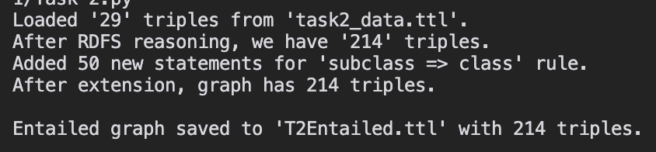

Verifying the 4 Derived Triples (8 marks)
In the code, verify_inferred_triples function has been implemented that checks whether each of the four new inferred triples appears in the final entailed graph. Specifically:
1. The RDFS closure in entailed_graph has already been computed.
2. Each triple in the “derived” list, its tested if (subject, predicate, object) is in entailed_graph.
3. If it is present, print True; otherwise, False.
Solution:
This confirms that the entailed graph contains the new statements from Task 2.A. Since each triple is found to be True, we verify that the original graph entails them.

